Illuminating insights from uber expeditionary analysis

Introduction

* ***Uber is a transportation company with an app that allows passengers to hail a ride and drivers to charge fares and get paid.***
* ***More specifically , Uber is a ridesharing company that hires independent contractors as drivers .***
* ***It’s one of many services today that contribute to the sharing economy , supplying a means of connecting existing resources instead of providing the physical resources themselves***

Problem definition and design thinking

* Empathy map

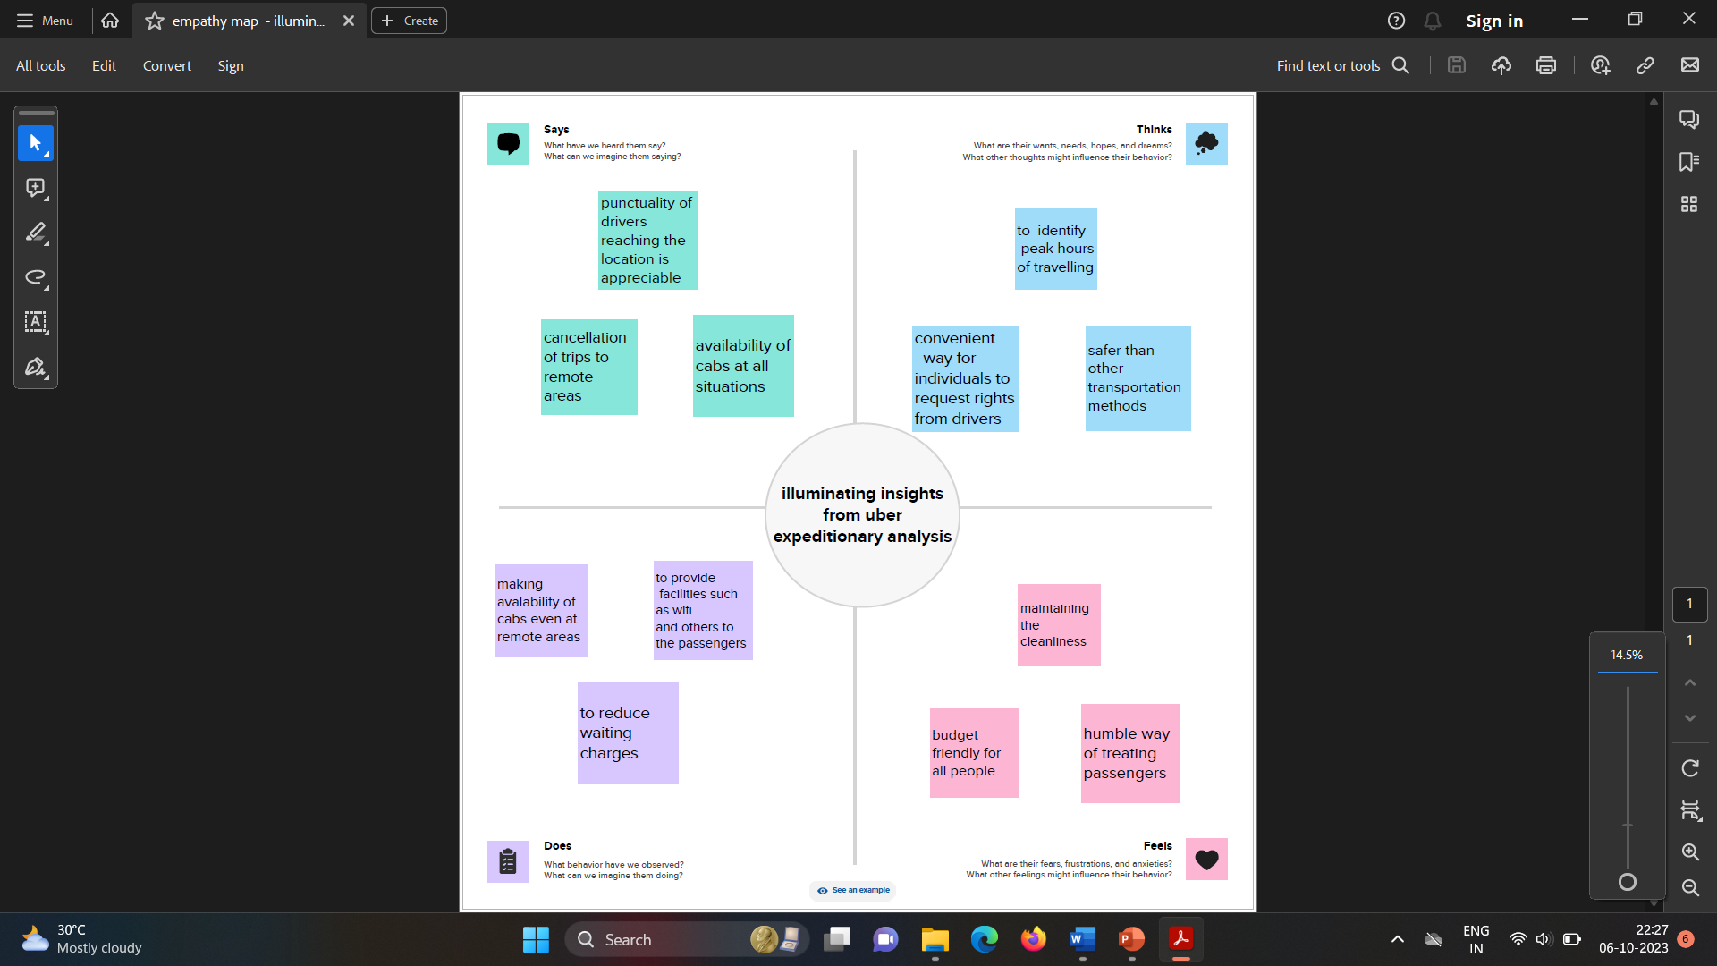

* Brainstorming map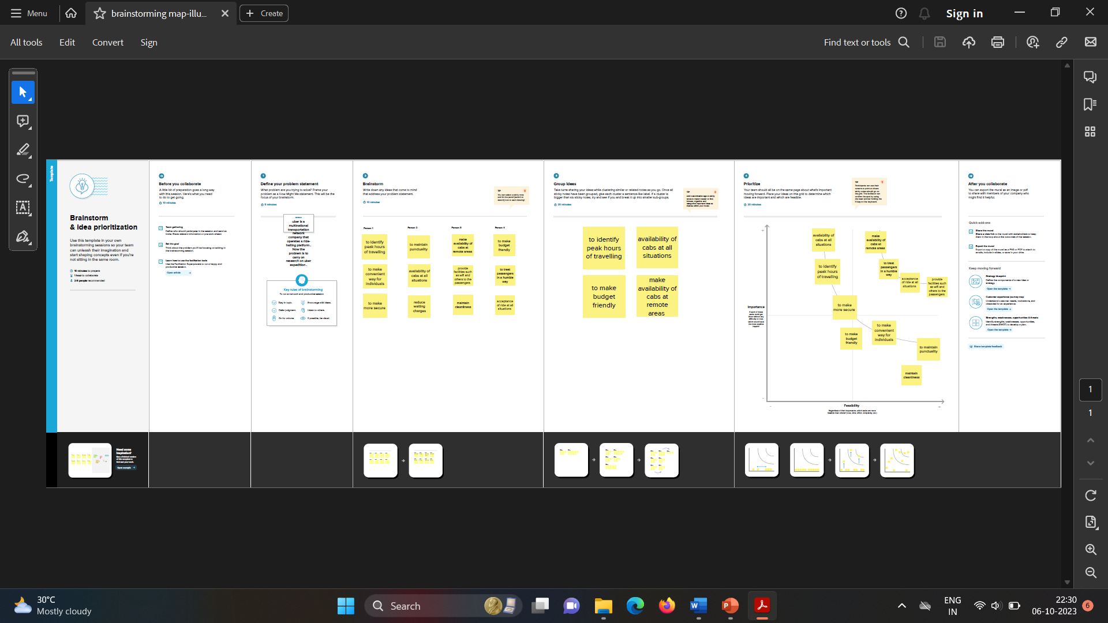

Result

* Dashboard

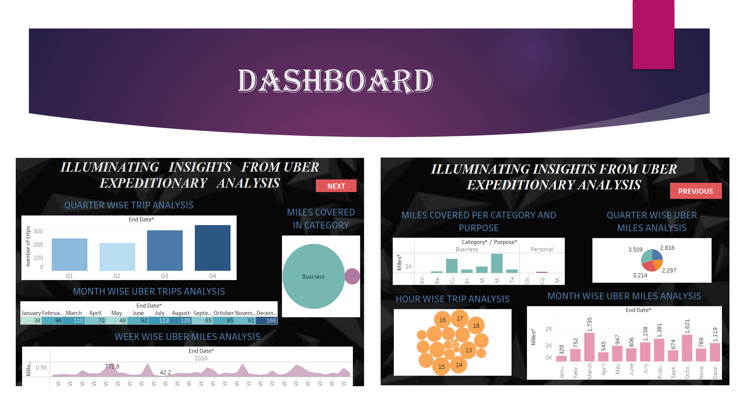

* Story

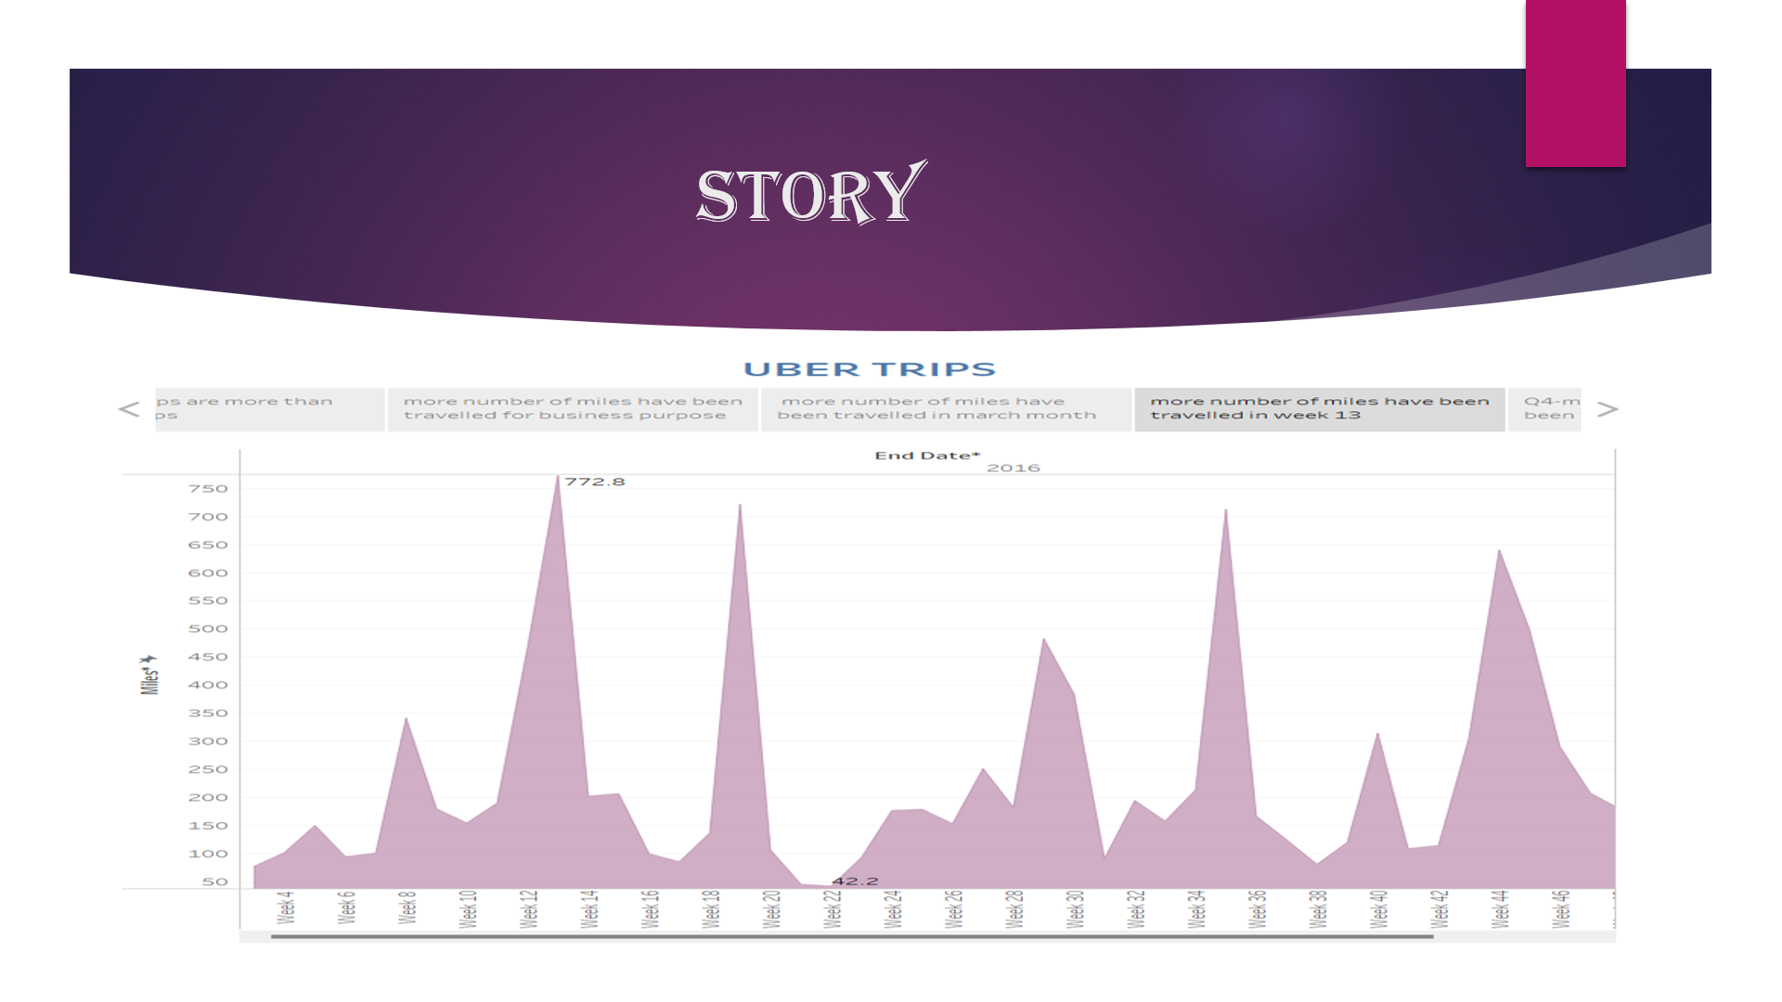

ADVANTAGES AND DISADVANTAGE

* ADVANTAGES

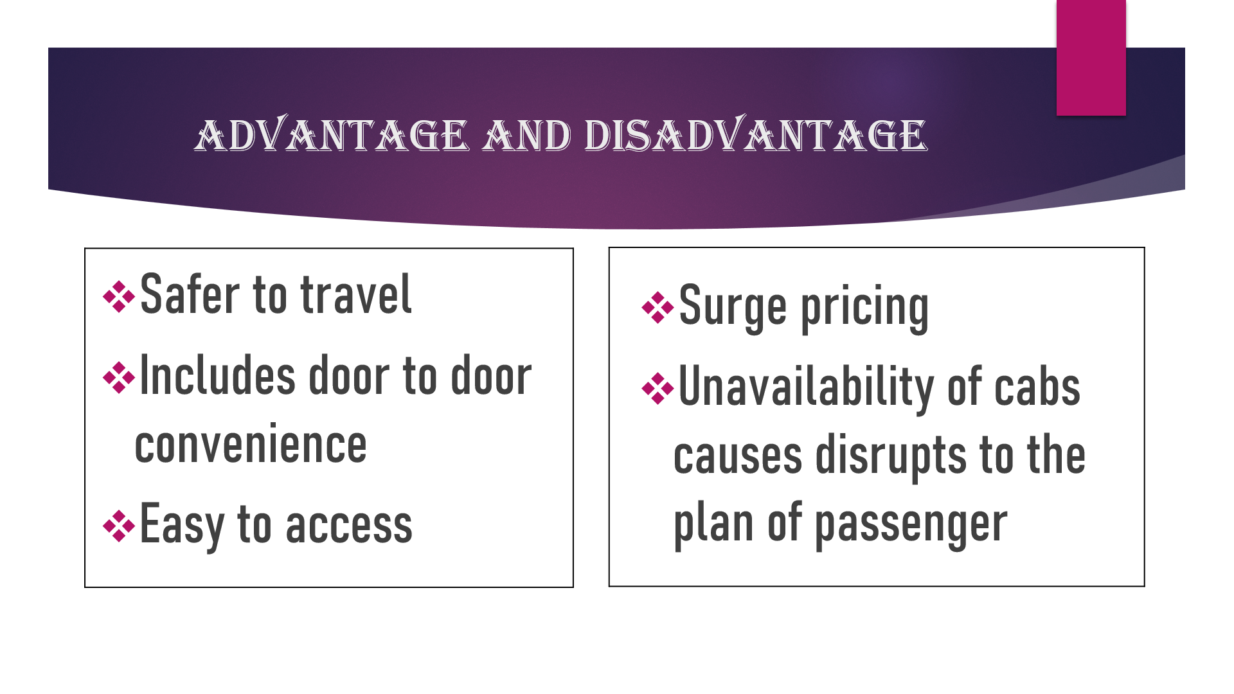

FUTURE SCOPE

* In the busy and frustrated world one need not run in the roads to look for a cab to travel . Each and everyone has a smartphone with which they can book a ride to their desired place .
* The scope for uber does not decrease as everyone in the world has to travel to some or the other place either for job or their personal work .
* Thus the scope for uber is raising each and everyday in the technically developing world .

CONCLUSION

* Uber has become a popular term among the youth , especially the traveler’s community and daily commuters . Even if anyone hasn’t used the service yet knows what uber is and what it means to order a taxi from the uber app .
* The credit for uber’s immense success goes to it’s affordability , originality , speed , and convenience on a ride , and the speed ensures a quick pick-up and drop facility